The Holy Bible is Not Jewish!
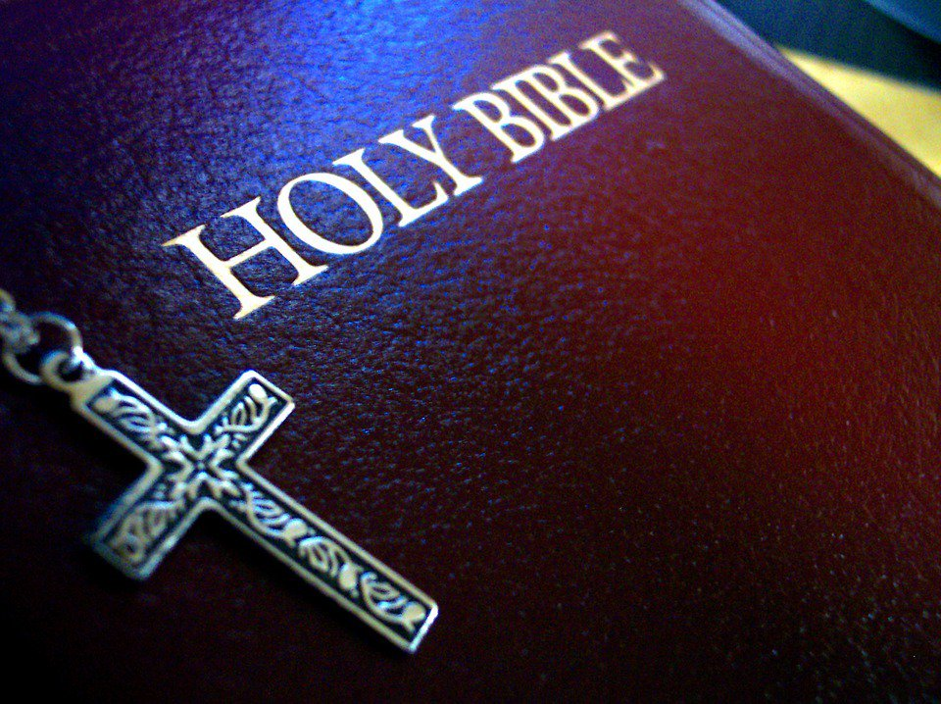

The statement is commonly made, even by those who should know better, that we Christians owe a debt to the Jews, for we got our Bible and our religion from them. While many people have been deceived into believing this, it is completely false. Part of the mistake comes from the complete confusion in the minds of nearly all people as to just what they mean by Jew. Are they referring to people of a certain race, or referring to a people of a certain religion, for the two are not the same? There are in Africa today, some pure-blooded negroes who are Jews by religion and there are in China today, some pure-blooded Mongolians who are Jews by religion. Likewise, there are some people today who are racially of the stock we know as Jews, but who have been converted to other religions.

First let's consider the claim we got our Bible and our religion from the Jews, as meaning Jews by religion. It is certain we didn't get the New Testament from them, for it condemns the Jewish religion throughout all the New Testament. But did we get the Old Testament from them? No, for several reasons in the first place, no Jew by religion existed before the return from the Babylonian captivity, shortly after 536 B.C. Their great historian Josephus writes, "So the Jews prepared the work. Jew is the name they are called by from the day that they came up from Babylon." The only books of the Old Testament that were written after the return from Babylon are, Kings, Chronicles, Ezra and Nehemiah (all of them historical, rather than doctrinal) Haggai, Zechariah and Malachi. In none of these do the Jews receive anything but rebuke for their wickedness, for their apostasy from the religion of the Old Testament. The late Rabbi Stephen F. Wise, formerly the Chief Rabbi of the United States said, "The return from Babylon and the introduction of the Babylonian Talmud mark the end of Hebrewism and the beginning of Judaism."

The learned Rabbi was correct in distinguishing the true religion of the Old Testament as Hebrewism for it was the religion of the real Hebrews, who were not Jews at all. Judaism, the religion of the Jews, is as the learned Rabbi says, based upon the Babylonian Talmud, which contains the supposed oral law. It was never reduced to writing as part of the Bible. This oral law gradually gained greater force among the Jews than the written law in the Bible, with which it often conflicted in Yahshua's day, the Babylonian Talmud was known as the Tradition of the Elders.

This is why Yahshua told the Jews:

"Well hath Esaias prophesied of you hypocrites, as it is written, This people honoreth Me with their lips, but their heart is far from Me. Howbeit, in vain do they worship Me, teaching for doctrines the Commandments of men. For laying aside the commandments of Yahweh that ye may keep your own tradition, * * making the word of God of none effect through your tradition which ye have delivered." Mark 7:6-13.

"Ye do err, not knowing the scriptures, nor the power of Yahweh." Matthew 22:29

"Woe unto you, Scribes and Pharisees, Hypocrites! for ye pay tithes of mint, anise and cumin and have omitted the weightier matters of the law, judgment, mercy and faith" Matthew 23:23

This was the religion of the Jews. As the learned Rabbi Stephen F Wise said, Judaism as distinguished from Hebrewism, the real religion of the Old Testament. Certainly Christianity took nothing from any Jewish religion for we have never taken any part of Christianity from the Talmud.

Well then, can it be said we got our Bible or our religion of Christianity from men of the Jewish race? No, it cannot. I haven't the time in the remainder of this lesson to give the Bible evidence in detail. I will have to reserve that for a later lesson. It can be clearly proven, both out of the historical books of the Bible and out of the only thorough history of the times written bay one living when the facts were still well known. Josephus' "Antiquities of the Jews", tells that the Jews were a people distinct and separate from Yahweh's people Israel, although living among them. The Jew were the Canaanite people who lived in Palestine, before Israel entered the promised land and who were not driven out. These Canaanite people, and the mixed offspring from intermarriage with the Israelites, were allowed to remain in the land while paying heavy tribute taxes.

The prophets who wrote the books of the Old Testament, were all of pure Israelite stock, from one or another of the 12 tribes of Israel. Moses, Jeremiah, Ezekiel, Habakkuk, Haggai anti Zechariah were of the tribe of Levi. Joshua and Samuel were of the tribe of Ephraim. Isaiah, Daniel and Zephaniah were of the house of David, Jonah was of the tribe of Zebulun. Hosea was of the tribe of Issachar.

When the Assyrians conquered and deported the people of the ten northern tribes, the Bible records that the Assyrians brought other people in from the Assyrian empire and settled them in Samaria, in place of the Israelites they had deported. Samaria is only the southern half of the territory occupied by these ten northern tribes. The northern half was Galilee and this was left vacant. When the kingdom of Judah was later deported to Babylon, for their seventy years captivity, their land was left with very little population. While they were gone, the Edomites who were descendants of Esau, mixed with Canaanite people, were forced out of their own land by pressure of invading Arab tribes, and moved westward into the vacant lands of Judah, occupying the southern half of the former kingdom of Judah.

Therefore, when a portion of the two tribes of Judah and Benjamin returned from the Babylonian captivity, they were too few in numbers to drive out the warlike Edomites and had to try to squeeze into the very little territory they had left. It was too small for them, so what was left of the tribe of Judah took the little territory remaining around Jerusalem and Benjamin was pushed to the north. They could not move next door into Samaria, as this area was occupied by the people the Assyrians had settled there. Benjamin had to leapfrog over them into the vacant territory of Galilee.

That the apostles and the majority of Christian converts came from the Benjaminites should not surprise us. When the kingdom was split in two upon the death of Solomon, Yahweh said He would leave Benjamin with Judah so that the house of David should have a light before them. In Yahshua's time the people of Benjamin were still the light bearers. In the New Testament all of the apostles were of the tribe of Benjamin except Judas Escariot, the only Jew among them. Judas came from the village of Kerioth in southern Judea. Iscariot is a corruption of Ish Kerioth, man of Kerioth. Paul tells us that he (Paul) was of the tribe of Benjamin and at the other apostles except Judas Escargot were from Galilee where the tribe of Benjamin settled after the return from Babylon.

This is confirmed by Yahshua. In Matthew 15:24 He said, "I am not sent but unto the I sheep of the house of Israel", in John chapter 10 Yahshua tells the Jews, "I am the good Shepherd and know My sheep and am known of Mine. But ye believe not because ye are not of My sheep, as I said unto you. My sheep hear my voice and I know them and they follow me" From the Savior's own tips we have the proof that the Jews are not of the tribes of Israel. Note carefully that He does not say that their unbelief keeps them from being of His sheep. He says the exact opposite, that the reason why they do not believe is that they are not of His sheep, the house of Israel.

Christianity and Judaism are completely and irreconcilably inconsistent. Whichever one is right, the other must be wrong for they mutually repudiate each other. A great part of Yahshua's reported words are His denunciation of the Jews for their religion, which He tells them is not that of the Old Testament. In John 5:46 Yahshua told them, "Had ye believed in Moses, ye would have believed Me: for he wrote of Me." In Luke 16:31 Yahshua said, "If they hear not Moses and the prophets, neither will they be persuaded through one rose from the dead." He was right, He did rise from the dead, but to this day they are not persuaded.

It is therefore clear, we did not get either our Bible or our Christian religion, either in whole or in part from those who were Jews, either by religion or by race. We owe them no debt, for they gave us nothing.

The statement is commonly made, even by those who should know better, that we Christians owe a debt to the Jews, for we got our Bible and our religion from them. While many people have been deceived into believing this, it is completely false. Part of the mistake comes from the complete confusion in the minds of nearly all people as to just what they mean by Jew. Are they referring to people of a certain race, or referring to a people of a certain religion, for the two are not the same. There are in Africa today, some pure blooded negroes who are Jews by religion and there are in China today, some pure blooded Mongolians who are Jews by religion. Likewise, there are some people today who are racially of the stock we know as Jews, but who have been converted to other religions.

First let's consider the claim we got our Bible and our religion from the Jews, as meaning Jews by religion. It is certain we didn't get the New Testament from them, for it condemns the Jewish religion throughout all the New Testament. But did we get the Old Testament from them? No, for several reasons in the first place, no Jew by religion existed before the return from the Babylonian captivity, shortly after 536 B.C.. Their great historian Josephus writes, "So the Jews prepared the work. Jew is the name they are called by from the day that they came up from Babylon." The only books of the Old Testament that were written after the return from Babylon are, Kings, Chronicles, Ezra and Nehemiah (all of them historical, rather than doctrinal) Haggai, Zechariah and Malachi. In none of these do the Jews receive anything but rebuke for their wickedness, for their apostasy from the religion of the Old Testament. The late Rabbi Stephen F. Wise, formerly the Chief Rabbi of the United States said, "The return from Babylon and the introduction of the Babylonian Talmud mark the end of Hebrewism and the beginning of Judaism."

The learned Rabbi was correct in distinguishing the true religion of the Old Testament as Hebrewism for it was the religion of the real Hebrews, who were not Jews at all. Judaism, the religion of the Jews, is as the learned Rabbi says, based upon the Babylonian Talmud, which contains the supposed oral law. It was never reduced to writing as part of the Bible. This oral law gradually gained greater force among the Jews than the written law in the Bible, with which it often conflicted in Yahshua's day, the Babylonian Talmud was known as the Tradition of the Elders.

This is why Yahshua told the Jews:

"Well hath Esaias prophesied of you hypocrites, as it is written, This people honoreth Me with their lips, but their heart is far from Me. Howbeit, in vain do they worship Me, teaching for doctrines the Commandments of men. For laying aside the commandments of Yahweh that ye may keep your own tradition, * * making the word of God of none effect through your tradition which ye have delivered." Mark 7:6-13.

"Ye do err, not knowing the scriptures, nor the power of Yahweh." Matthew 22:29

"Woe unto you, Scribes and Pharisees, Hypocrites! for ye pay tithes of mint, anise and cumin and have omitted the weightier matters of the law, judgment, mercy and faith" Matthew 23:23

This was the religion of the Jews. As the learned Rabbi Stephen F Wise said, Judaism as distinguished from Hebrewism, the real religion of the Old Testament. Certainly Christianity took nothing from any Jewish religion for we have never taken any part of Christianity from the Talmud.

Well then, can it be said we got our Bible or our religion of Christianity from men of the Jewish race? No, it cannot. I haven't the time in the remainder of this lesson to give the Bible evidence in detail. I will have to reserve that for a later lesson. It can be clearly proven, both out of the historical books of the Bible and out of the only thorough history of the times written bay one living when the facts were still well known. Josephus' "Antiquities of the Jews", tells that the Jews were a people distinct and separate from Yahweh's people Israel, although living among them. The Jew were the Canaanite people who lived in Palestine, before Israel entered the promised land and who were not driven out. These Canaanite people, and the mixed offspring from intermarriage with the Israelites, were allowed to remain in the land while paying heavy tribute taxes.

The prophets who wrote the books of the Old Testament, were all of pure Israelite stock, from one or another of the 12 tribes of Israel. Moses, Jeremiah, Ezekiel, Habakkuk, Haggai anti Zechariah were of the tribe of Levi. Joshua and Samuel were of the tribe of Ephraim. Isaiah, Daniel and Zephaniah were of the house of David, Jonah was of the tribe of Zebulun. Hosea was of the tribe of Issachar.

When the Assyrians conquered and deported the people of the ten northern tribes, the Bible records that the Assyrians brought other people in from the Assyrian empire and settled them in Samaria, in place of the Israelites they had deported. Samaria is only the southern half of the territory occupied by these ten northern tribes. The northern half was Galilee and this was left vacant. When the kingdom of Judah was later deported to Babylon, for their seventy years captivity, their land was left with very little population. While they were gone, the Edomites who were descendants of Esau, mixed with Canaanite people, were forced out of their own land by pressure of invading Arab tribes, and moved westward into the vacant lands of Judah, occupying the southern half of the former kingdom of Judah.

Therefore, when a portion of the two tribes of Judah and Benjamin returned from the Babylonian captivity, they were too few in numbers to drive out the warlike Edomites and had to try to squeeze into the very little territory they had left. It was too small for them, so what was left of the tribe of Judah took the little territory remaining around Jerusalem and Benjamin was pushed to the north. They could not move next door into Samaria, as this area was occupied by the people the Assyrians had settled there. Benjamin had to leapfrog over them into the vacant territory of Galilee.

That the apostles and the majority of Christian converts came from the Benjaminites should not surprise us. When the kingdom was split in two upon the death of Solomon, Yahweh said He would leave Benjamin with Judah so that the house of David should have a light before them. In Yahshua's time the people of Benjamin were still the light bearers. In the New Testament all of the apostles were of the tribe of Benjamin except Judas Escariot, the only Jew among them. Judas came from the village of Kerioth in southern Judea. Iscariot is a corruption of Ish Kerioth, man of Kerioth. Paul tells us that he (Paul) was of the tribe of Benjamin and at the other apostles except Judas Escargot were from Galilee where the tribe of Benjamin settled after the return from Babylon.

This is confirmed by Yahshua. In Matthew 15:24 He said, "I am not sent but unto the I sheep of the house of Israel", in John chapter 10 Yahshua tells the Jews, "I am the good Shepherd and know My sheep and am known of Mine. But ye believe not because ye are not of My sheep, as I said unto you. My sheep hear my voice and I know them and they follow me" From the Savior's own tips we have the proof that the Jews are not of the tribes of Israel. Note carefully that He does not say that their unbelief keeps them from being of His sheep. He says the exact opposite, that the reason why they do not believe is that they are not of His sheep, the house of Israel.

Christianity and Judaism are completely and irreconcilably inconsistent. Whichever one is right, the other must be wrong for they mutually repudiate each other. A great part of Yahshua's reported words are His denunciation of the Jews for their religion, which He tells them is not that of the Old Testament. In John 5:46 Yahshua told them, "Had ye believed in Moses, ye would have believed Me: for he wrote of Me." In Luke 16:31 Yahshua said, "If they hear not Moses and the prophets, neither will they be persuaded through one rose from the dead." He was right, He did rise from the dead, but to this day they are not persuaded.

It is therefore clear, we did not get either our Bible or our Christian religion, either in whole or in part from those who were Jews, either by religion or by race. We owe them no debt, for they gave us nothing.

