Biblical Dietary Laws
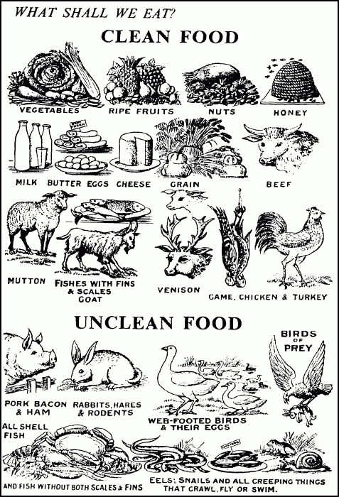

Clean Animals you CAN eat:
Whatever animals that have divided or cloven hoofs and chews its cud you may eat. Lev. 11:2; Deut 14:6.
Fishes that have fins and scales may be eaten (Bass, croppie, flounder, cod, haddock, pike, salmon, sunfish, mackerel, snapper, trout, perch, smelt, tuna, etc.). Lev. 11:9; Deut 14:9.
All clean birds can be eaten (e.g., chicken, turkey, pheasant, quail, grouse, partridge, etc.). Deut 14:11, 20.
Insects-locust, bald locust, grasshoppers. Lev. 11:22.
If a clean animal dies it is considered unclean until evening. Lev. 11:39-30.
Animals which you can eat--ox, sheep, goats, deer, roebuck, gazelle, fallow deer, wild goat, antelope, buffalo, caribou, elk, ibex, wild ox, moose, chamois. Deut. 12:15,22; Deut 14:4-6.

Clean Animals you CAN'T eat:
Camel (does not have a divided hoof). Lev. 11:4; Deut. 14:7.
Rabbits, hares, and rock hyrax (does not have a divided hoof). Lev. 11:5-6; Deut. 14:7.
Cattle which either do not chew the cud or divide the hoof (horse, donkey, quagga, llama, etc.). Lev. 11:4; Deut 14:7.
Swine or hog (does not chew the cud). Lev. 11:7; Deut. 14:8.
Creeping things-weasel, mouse, tortoise, turtle, sand reptile, ferret, chameleon, gecko, frogs, toads, snakes, crocodile, lizard, squirrel, raccoon, mole. Lev. 11:29-31.
All water life that does not have fins and scales are not to be eaten (e.g., shrimp, lobster, snails, clams, shark, shell fish, eels, catfish, scallop, octopus, etc.). Lev. 11:10-12; Deut 14:10.
Every creeping thing that flies is unclean. Deut 14:19.
Unclean birds-Eagle, buzzard, osprey, vultures, kite, ravens, owl, night hawk, ostrich, hawk, little owl, cormorant, great owl, falcon, swan, pelican, stork, herons, hoopoe, bats (and the eggs of unclean birds). Lev. 11:13-19; Deut 14:12-18.
All winged insects that walk on all fours. Lev. 11:20.
Whatever crawls upon its belly or is multi-footed among all creeping things that creep on the earth. Lev. 11:42.
Whatever goes on its paws, among all kinds of animals that go on all fours, are unclean (e.g., dogs, cats, coyote, bears, foxes, etc.). Lev. 11:27.

PIG & PORK FACTS
THE pig or swine is a very popular food item with most Christians. Yet Christians are unaware that the God they profess to believe in had condemned the eating of swine's flesh.
The condemnation was based on some very sound biological principles.
Here are some facts on pork that prove it to be a very unhealthy food to eat:
A pig is a real garbage gut.
It will eat anything including urine, excrement, dirt, decaying animal flesh, maggots, or decaying vegetables.
They will even eat the cancerous growths off other pigs or animals. The meat and fat of a pig absorbs toxins like a sponge.
Their meat can be 30 times more toxic than beef or venison.
When eating beef or venison, it takes 8 to 9 hours to digest the meat so what little toxins are in the meat are slowly put into our system and can be filtered by the liver. But when pork is eaten, it takes only 4 hours to digest the meat. We thus get a much higher level of toxins within a shorter time.
Unlike other mammals, a pig does not sweat or perspire. Perspiration is a means by which toxins are removed from the body. Since a pig does not sweat, the toxins remain within its body and in the meat. Pigs and swine are so poisonous that you can hardly kill them with strychnine or other poisons.
Farmers will often pen up pigs within a rattlesnake nest because the pigs will eat the snakes, and if bitten they will not be harmed by the venom. When a pig is butchered, worms and insects take to its flesh sooner and faster than to other animal's flesh. In a few days the swine flesh is full of worms.
Swine and pigs have over a dozen parasites within them, such as tapeworms, flukes, worms, and trichinae. There is no safe temperature at which pork can be cooked to ensure that all these parasites, their cysts,and eggs will be killed. Pig meat has twice as much fat as beef. A 3 oz T bone steak contains 8.5 grams of fat; a 3 oz pork chop contains 18 grams of fat. A 3 oz beef rib has 11.1 grams of fat; a 3 oz pork spare rib has 23.2 grams of fat. Cows have a complex digestive system, having four stomachs. It thus takes over 24 hours to digest their vegetarian diet causing its food to be purified of toxins.
In contrast, the swine's one stomach takes only about 4 hours to digest its foul diet, turning its toxic food into flesh.
The swine carries about 30 diseases which can be easily passed to humans.
This is why God commanded that we are not even to touch their carcase (Leviticus 11:8).
The trichinae worm of the swine is microscopically small, and once ingested can lodge itself in our intestines, muscles, spinal cord or the brain. This results in the disease trichinosis.
The symptoms are sometimes lacking, but when present they are mistaken for other diseases, such as typhoid, arthritis, rheumatism, gastritis, MS, meningitis, gall bladder trouble, or acute alcoholism. The pig is so poisonous and filthy, that nature had to prepare him a sewer line or canal running down each leg with an outlet in the bottom of the foot. Out of this hole oozes pus and filth his body cannot pass into its system fast enough. Some of this pus gets into the meat of the pig. There are other reasons grounded in biological facts that could be listed to show why pigs and swine should not be eaten. But a true Christian should only need one reason why not to eat this type of food because God prohibited it.

"And the swine, because it divides the hoof, yet does not chew the cud, it is unclean unto you: you shall not eat of their flesh, nor touch their dead carcase." - Leviticus 11:7,8; Deuteronomy 14:8

Those who say Christ abolished the law condemning pork are motivated by their stomach not Scripture.
The problems with pork are biological, and Christ never changed the laws of biology.

