THE MIGRATIONS OF THE TWELVE TRIBES OF ISRAEL (THE CAUCASIANS)
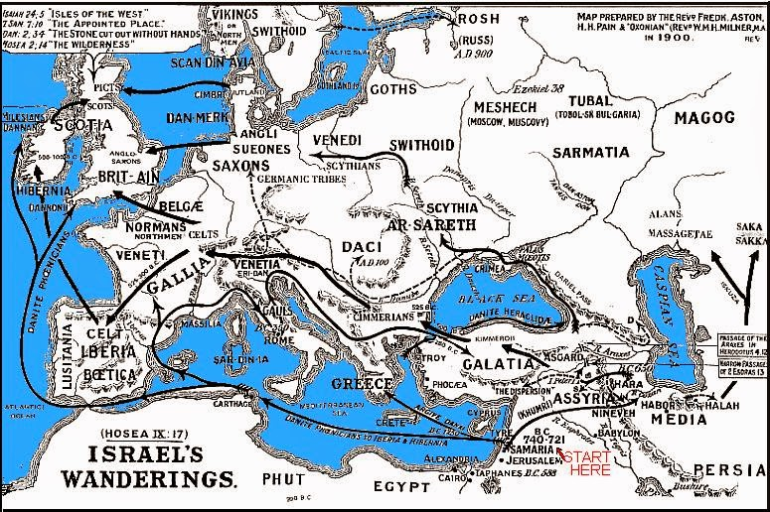
By: Bertrand L. Comparet

THOUGH we are supposed to be living in an enlightened world, and in many ways, we are, when it comes to understanding who or where the Twelve Tribes of Israel are in the world today, we find only a limited amount of information, and much of it is conjecture. We pray that the following information, along with the Migration Map on the other side will be helpful in shedding lighter and understanding on this most important and timely subject.

We will endeavor to show that the Twelve Tribes of Israel in the world today are none other than the peoples which comprise the Anglo-Saxon, Celtic, Germanic, Scandinavian and kindred peoples. Since they are scattered throughout the world, it is difficult to have an accurate estimate of how many Israelites there are living at this time, but there are some who estimate that there are between six and seven hundred million. The promise which the Lord our God made (some 3800 years ago) to Abraham, Isaac and Isaac’s sons (the Sax-sons) as recorded in the book of Genesis, has come to pass. (God reiterated the promise specifically to Jacob, who was given the name (“Israel”).

The first time that Abraham was told that his progeny would be a blessing to all nations of the
world, and would be a great host of people, is found in Genesis 12, but for this study we will consider chapter 22 where the Lord appears the second time to Abraham to repeat and confirm what we call today the “Abrahamic Covenant.”

Let’s consider verses 15-18 which state:

“And the angel of the Lord called unto Abraham out of heaven the second time and said, By myself have I sworn, saith the Lord, That in blessing I will bless thee, and in multiplying I will multiply thy seed as the stars of the heaven, and as the sand which is upon the seashore; and in thy seed shall all the nations of the earth be blessed, Because thou hast obeyed my voice.”

It is very evident that for many centuries the peoples which comprise Anglo-Saxondom have not only taken the gospel of Jesus Christ to practically every nation and people in the world, but they have also been a blessing in other ways to the “have-not” nations of the world. It is important to notice that the Lord reminds Abraham that the reason why his seed would be a blessing to the other nations was that they have obeyed God’s voice and commandments in these last days. The only nations throughout the world today which have made the Holy Bible their National Book of faith are the Anglo-Saxon, Germanic, Scandinavian and kindred peoples. The peoples of Japan, China India, and Africa, etc. have their pagan Gods but, among the peoples of Anglo-Saxondom, you will always find the Bible and worship of Jesus Christ, just as the Bible states that Israel would do.

Most Christians are aware that the Israelites were carried into captivity, but many know little about the details. A short synopsis of this story is found in 2 Kings 18. There we read of this deportation of Israel and, a few years later, most of Judah. In approximately 730 B.C. Shalmaneser (king of Assyria) invaded Israel, and we read in verses 11 & 12:

"And the King of Assyria did carry away Israel unto Assyria, and put them in Halah and in Harbor by the river of Gozan, and in the cities of the Medes, because they obeyed not the voice of the Lord their God, but transgressed his covenant...”

In verse 13 we read where (seven years later) the Assyrian army came up against the remaining cities of Judah and took them. Only Jerusalem remained under King Hezekiah’s control.

Eventually the city of Jerusalem was also destroyed as the people continued to sin. In the year 596 B.C., or thereabouts, Nebuchadnezzar, King of Babylon, came and besieged Jerusalem, and took the inhabitants (approx. 22,000) into what we call the Babylonian Captivity.
This is a short history in a nutshell, so to speak, of Israel’s deportation and subsequent captivity. However, the important thing that we need to remember is that, when almost the entire population of all Twelve tribes of Israel were taken captive by the armies of Assyria, they were placed in the area of the Caucasus Mountains to the North of their Homeland. There they remained for approximately one hundred years and became known as Caucasians. The name Caucasian has remained as part of their identity ever since that time. Most people have no idea whatsoever of the connection between the Caucasians and the Israelites of Bible history and prophecy.

In fact, the great majority of the peoples of Anglo-Saxondom today have little, if any, idea as to why they happen to be called “Caucasians”. When a person seeks employment, it is not unusual to find the question asked as to whether they are of Caucasian descent. Most people answer "yes" without thinking of the historic reason for this designation.

Secular history records that the Twelve Tribes were never really lost but had just taken on a different name. The map above shows the different routes taken by the Israelites when they left the area of the Caucasus mountains and migrated over into Europe during the subsequent years. They were not known as “Israelites “during this trek Westward, but by the various names as shown on the map. Later, as they settled in various parts of Europe, they took on the names by which we know the countries today. Collectively, we call them the “Western Christian nations”. As the movement West continued, we find that a representative number of the Twelve tribes gathered here on this great North American Continent.

The prophets Isaiah and Micah prophesied that in the last days a great and mighty nation would arise. It would be a prosperous nation, and be called Jacob, i.e. ISRAEL, and this great prosperous nation and its people would honor the Lord Jesus Christ.

We are told that many nations would come there to be taught of our God. Today millions of people from other cultures and races are seeking to migrate to America and Canada to have a share in our material blessings and the freedoms enjoyed here. Many who have already come have learned to know the Lord Jesus Christ as their Savior.

Micah writes of this thrilling time when we are privileged to live in this great Kingdom nation. In chapter 4:1-2 we read:

“And it shall come to pass that the mountain (i.e. Kingdom) of the house of the Lord (i.e. the Twelve Tribes of Israel ... or Anglo-Saxondom) shall be established in the top (i.e. the head, the chief or the greatest) of the mountains (Kingdoms) and people shall flow into it. And many nations, or peoples, shall come and say, Come, let us go up to the mountain of the Lord, and to the house of Jacob; and he shall teach us of his ways.”

The prophet Hosea also prophesies about the future restoration of Israel, which has now been fulfilled for the most part. We read of this in Hosea 1:10.

“Yet the number of the children of Israel shall be like the sand of the sea, which cannot be measured nor numbered; and it shall come to pass that, in the place where it was said unto them, Ye are not my people, (we are called Gentiles) there it shall be said unto them, Ye are the sons of the living God” (i.e. Christians)

May the Lord help us to realize that the Caucasian Race (the peoples which comprise Anglo-Saxondom) are being judged by Almighty God because we have sinned against Him in not keeping His laws. The prophet Isaiah, speaking to the nations of Israel, states in chapter 42:24:

“Who gave Jacob for a spoil, and Israel to the robbers? Did not the Lord., he against whom we have sinned? for they would not walk in his ways, neither were they obedient unto his laws “

Isaiah was speaking of our time and referring to Jacob-Israel’s descendants (as we have mentioned ... the peoples of Anglo-Saxondom). Today America is being spoiled, because we have forsaken the laws of our Lord Jesus Christ.

The only answer to England and America’s many problems is for us to turn to the Lord our God and obey His righteous laws as they relate to society. In 2 Chronicles 7:14 we read:

"IF MY PEOPLE, WHO ARE CALLED BY MY NAME, SHALL HUMBLE THEMSELVES, AND PRAY AND SEEK MY FACE, AND TURN FROM THEIR WICKED WAYS, THEN WILL I HEAR FROM HEAVEN, AND WILL FORGIVE THEIR SIN, AND WILL HEAL THEIR LAND”.

May the Lord Jesus Christ help us to awaken to our Divine Destiny and Birthright, so that we may be about doing the will of the Lord here upon the earth.

