The Holiest Name!
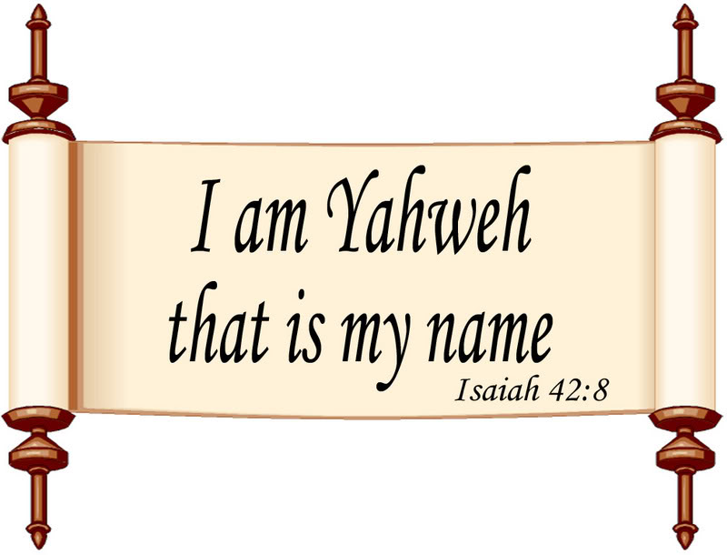

The name of our heavenly father was confirmed to Moses in Exodus 3:15.
Exodus 3:15 "And said also {The Mighty One} to Moses, 'say to the children of Israel, YAHWEH, {Mighty One} of your fathers, {Mighty One} of Abraham, {Mighty One} of Isaac, and {Mighty One} of Jacob has sent me to you; THIS IS MY NAME FOREVER, the name by which I am to be remembered from generation to generation."
Moses recorded it in Hebrew, and it has been kept for centuries by the Ministers in the numerous scrolls that they made. Most English Bibles have replaced that name with "the LORD" (all upper case), which is not a name, but a title. This results in the true name being removed from the scriptures in almost 7000 places.
YHWH or YHVH (Yahweh) is the God of Israel, His chosen Race (Anglo-Saxon).
Does it matter what you call Him?
Does He even need to have a name for proper worship, as the deities of all other religions do? Some believe that He knows who you mean no matter what you call Him. But have they considered that refusing to revere His personal Name demonstrates dishonor for the One they worship, as well as blatant defiance of His Word? He tells us precisely that in Malachi 2:2.
Our Heavenly Father clearly wants his people to use his name. Here is one of the first statements from Yahweh about using his name:
Exodus 3:15 "And said also {The Mighty One} to Moses, 'say to the children of Israel, YAHWEH, {Mighty One} of your fathers, {Mighty One} of Abraham, {Mighty One} of Isaac, and {Mighty One} of Jacob has sent me to you; THIS IS MY NAME FOREVER, the name by which I am to be remembered from generation to generation."

We are also told in Psalms to use his name:
Psalms 68:4 Sing unto Elohim, sing praises to his name; extol him that rideth upon the heavens BY HIS NAME YAH (poetically used for Yahweh in the Hebrew), and rejoice before him.
Psalms 105:1 Oh give thanks unto YAHWEH, CALL UPON HIS NAME; make known among the peoples his doings.
The name of Messiah, the son, is Yahshua, which means "Yahweh is salvation" or "Yahweh saves".
When we use this name, we are honoring Yahweh, because we are actually saying "Yahweh is salvation". Yahshua always directed the focus toward his father. And we now see, even in his name, he directs the focus toward his father (hence directing it toward himself, as He was Yahweh in the flesh).
HIS WORDS WERE HIS FATHER'S:
John 14:10 "...the words that I say unto you I speak not from myself: but the Father abiding in me doeth his works."
THE POWER WAS HIS FATHER'S:
John 14:28 "...I go unto the Father: for my Father is greater than I."
HE INSTRUCTED US TO PRAY TO THE FATHER:
Luke 11:2 "...When ye pray, say, Our Father which art in heaven, Hallowed be thy name."
Names are not normally translated from one language to another, but transliterated; spelled in the second language so it is pronounced as in the original language. From what we have seen explained about the names of the Almighty Father and the Son, these names should be given honor and pronounced as in the original language; especially "Yahweh", since he said this was his name forever. So many names have been transliterated in the Bible, the Prophets, the Patriarchs and even Satan! Why then was the name "Yahweh," which is more important than all of these, substituted with "The LORD" or "God" in direct defiance to the first three scriptures at the top of this page? Salvation in no other name:
Joel 2:31 (ASV) The sun shall be turned into darkness, and the moon into blood, before the great and terrible day of Yahweh cometh. 32 And it shall come to pass, that whosoever shall call on the name of Yahweh shall be delivered; for in mount Zion and in Jerusalem there shall be those that escape, as Yahweh hath said, and among the remnant those whom Yahweh doth call. [Verse 31 is clearly an "end time" statement.]

NOTE: The footnotes in most translations for Romans 10:13 and Acts 2:21, refer to Joel 2:31,32 above. Paul and Peter were quoting Joel, using Yahweh, not "Lord": Roma 10:13 (KJV) For whosoever shall call upon the name of {Yahweh} shall be saved. Acts 2:21 (KJV) And it shall come to pass, [that] whosoever shall call on the name of {Yahweh} shall be saved. Acts 4:10 (KJV) Be it known unto you all, and to all the people of Israel, that by the name of Yahshua the Messiah of Nazareth, whom ye impaled, whom Yahweh raised from the dead, [even] by him doth this man stand here before you whole. 11 This is the stone, which was set at nought of you builders, which is become the head of the corner. 12 Neither is there salvation in any other: for there is none other name under heaven given among men, whereby we must be saved. [Since the name "Yahshua" means "Yahweh is salvation", saying "Yahshua" still calls upon (evokes) the name of Yahweh.]
The lesson for us comes down to this: You cannot worship properly without using His proper, personal Name. His Name defines the Father as well as the one worship that is uniquely His. The only True Worship in the Bible is done in and through His revealed Name. We learn in Revelation 7:3, 14:1, and 22: 1-4 that the 144,000 faithful who are sealed in the end days are sealed with His Name in their foreheads. His Name separates True worshipers from the false and will give them literal protection from tribulation in the latter days. The heathens had to come out of their false worship and adhere to the true Name. True Worship and His Name go together and cannot be separated.
If there is one truth that is clearly shown throughout Scripture, it is this:
His Name and True Worship go hand in hand, they cannot be separated. He prohibits man from substituting His Name just as He disallows any worship other than what He prescribes.

AS ONE SHOULD NOW SEE, USING THESE NAMES, AND NOT SUBSTITUTES, IS VERY IMPORTANT!

