WHITE LIVES MATTER
Aryan Freedom Network
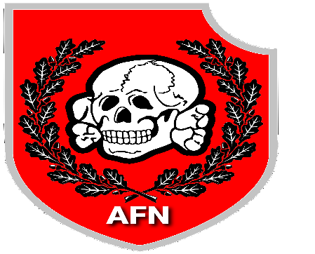
WHITE-POWER.ORG

